Using Blending Modes with Layers

* Blending modes can also be used to blend entire layers with each other.
* A blending mode can be assigned to any layer that appears above another layer
  + This causes the colors in the top layer to “blend” with, and change, the appearance of the colors in all layers beneath it

# How

1. To use a **blending mode** on a layer, begin by accessing the **Layers Palette**. Select that **layer** that you want to affect that is uppermost in the layer stack.
   1. If the stack includes layers that you do NOT want to affect, you need to reorganize your image to ensure that those layers are listed above the selected layer.
   2. Then **select** the desire **blending mode** from the **pop-up menu in the upper right corner** of the **Layers** palette

Layer Masks

# What is a Layer Mask?

* A **layer mask** is a special area that is created on a layer to hide (or mask) part of that layer
* When you create a layer mask, it looks like you have deleted part of the layer
  + However, the entire layer is still there, and the ‘hidden’ portions can easily be made visible again
* These makes are particular useful when two or more images need to be blended together

# Instructions for creating Masks

* 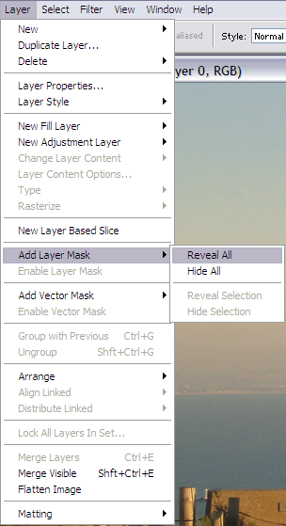Before creating a **layer mask**, the layer that will have a mask applied to it must be selected in the Layers Palette
  + If necessary, the layer transparency must be unlocked
* After select the layer and ensuring that layer transparency is unlocked, click the **Layer Mask** button at the bottom of the **Layers** Palette

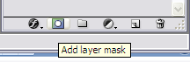



* + The same command is found by choosing **Layer > Layer Mask > Review All.** This causes a **Layer Mask** thumbnail to appear in the **Layers** palette
  + IF PART OF YOUR IMAGE IS SELECTED JUST BEFORE YOU CREATE A LAYER MASK, THE SLECTED AREA BECOMES A MASK
  + If you need to return to a **Layer Mask** and edit it, the **Layer Mask** thumbnail must be clicked in the **Layers** palette
* The Layer Mask can then be created using the painting and eraser tools and the following colors:
  + Black
  + White
  + Various shades of gray
* 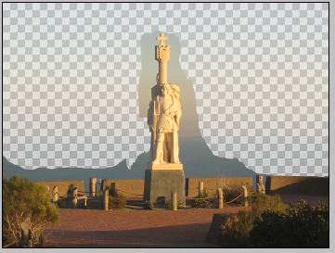When you paint on the **Masked Layer** with black as the foreground color, the **Mask** is actually created, causing the painted portions of the layer to be hidden.
* 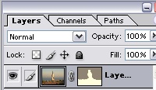As you paint, the layer mask thumbnail is automatically updated to show any changes to the masked area

Displaying Layer Masks

Painting with various shades of gray creates various levels of opacity in the **Layer Mask**.

**Gradients** made from black, white, and gray can also be used to create **layer masks** that “fade out”

So far, you have only been able to see the effects of a **Layer Mask** rather than the **mask** itself. However, there is a way you can display the **mask** on screen. When you open the **Channels** palette, a thumbnail of any **Layer Mask** assigned to the currently selected layer is displayed below the color channels in the channel list. If you double click on the layer mask thumbnail, the **Layer Mask Display Options** dialog box opens.

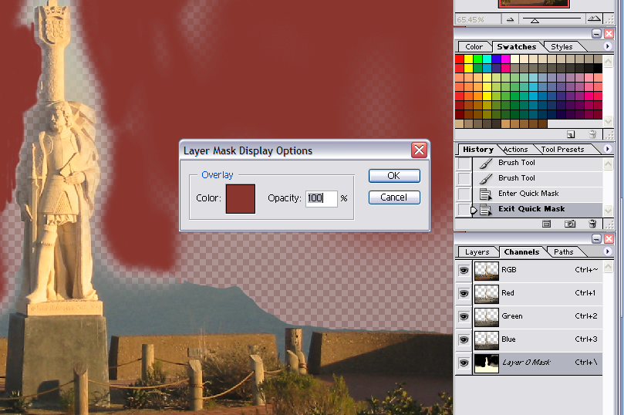

Click the **Visibility** toggle to turn the layer mask display on and off

Double click the layer mask thumbnail to open the **Layer mask Display Options** dialog box

When you paint on the **Masked Layer** with white as the foreground color (or erase with white as the background color), the mask is removed

Determines how easy it is to see through the **Layer Mask**



# Linking Layer Masks and Layers

In the **Layers** palette, a chain (linking) icon appears between the **Layer Mask** thumbnail and the **layer** thumbnail. This icon indicates that the **Layer Mask** is linked to the layer.

* In other words, if you use the Move Tool to move the layer in the image window, the **mask** will move with it. Linking can be turned on or off by clicking on the **Linking Icon**.
  + When linking is off, the layer mask and layer can be moved independently of each other in the image window.